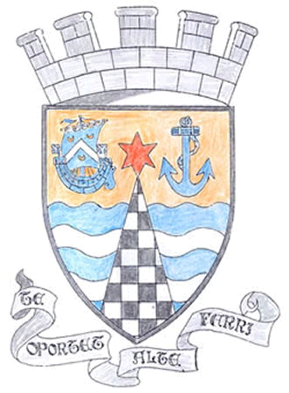
Tayport Ferryport-On-Craig Community Council

Agenda for Annual General Meeting of Community Council to be held on
Monday 5th May 2025 at 19:00hrs in the Burgh Chambers

19:00 Apologies
Declarations of Interest
` Minutes of last meeting

19:05 Matters Arising from previous Meeting

19:20 Report from the Chair

19:30 Treasurer’s Report

19:40 Police matters

19:45 Foodbanks Report

19:50 Fife Council and Other Correspondence

1. Report from sub committee on Christmas lights funding
2. Taybridgehead Forum Meeting in Dolphin Centre on 23rd April
3. Defibrillator at Gregory Hall
4. Playpark at East Common
5. Bridge to Community Garden
6. Fife Licensing Board Statutory duty to inform Community Council of
Licensing Applications

2010 Planning Applications

Nil

20:15 Fife Councillors Report

20:25 Questions for Fife Council

20:40 AOCB

21:00 Date of next meeting

G M Beat Secretary

