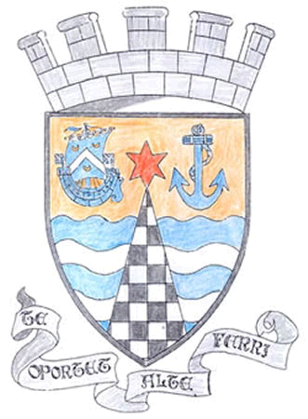
Tayport Ferryport –On-Craig

Community Council

MINUTES OF THE MEETING OF
THE TAYPORT FERRYPORT ON CRAIG COMMUNITY COUNCIL
HELD IN THE BURGH CHAMBERS ON MONDAY 2nd DECEMBER 2019 AT 19:00 HRS

Present: Chair: Mr D Gray: Secretary: Mr G M Beat: Treasurer: Mr J Kinnear
Mrs M Taylor, Mrs S Walker, Mrs L White, MS N Walker,

In Attendance: Councillor Tim Brett , Councillor Bill Connor

Apologies: Mrs H Lowe , Messrs D Myles , M Mitcham

Declarations of Interest: Mr J Kinnear ref Larick Centre

Minutes: The Minutes of the meeting held on 4th November were agreed as an accurate record .

Matters arising from the previous minutes:

1. Letter of thanks sent to Reverend Brian Oxburgh for his contribution over his years at Tayport Parish
Church to the Church Members and the residents of Tayport
2. Letter of thanks sent to Tayport Charity Shop for their donation towards the Christmas Lights .
3. Tree planting to commemorate Mrs Banks 100th Birthday took place on 28th November .
4. Tayport Community Council now own the Coinbox at the foot of Banknowe Drive . . .

Agenda items/Discussion | Action
Police Matters:

Written Report appended .

Foodbanks Report:

No report.

Treasurer’s Report  Christmas Tree purchased thanks to a donation . | .
Christmas Lights Report:

Thanks to the many businesses and individuals who helped make it a very successful evening and to Fife Council Electricity Group and Blachere lighting for all of the lights going on at the right time and staying on . There were 22 taking part in our first ever Santa run , including 13 children . Thanks to Robert Bates for setting them off , Derek and Lynda for organising on the night and the Marshals who made sure they did not run to Newport .

Tay Bridgehead Forum Report:

A constitution has been established and members have been asked to endorse this and also the minutes of the last meeting . Attending this meeting and speaking on behalf of the Dementia Support Group was Ruth Mc Cabe .

Fife Council and Other Correspondence:

1. Charging points for Electric Cars have been installed at Tayport Harbour and will shortly be fully
connected .
2. Fife Health and Social Care Partnership – briefing to Community Councils giving an Update on Out of
Hours Urgent Care
3. Fife Council having consultation over playparks and funding for upgrading and replacement .
£1000 grant via Dolphin Centre for container and play equipment to be based at Shanwell Road South
4. Discussion on projects for Community Payback – Unpaid Work Scheme
5. Discussion on flooding in Banknowe/Top Park area .
6. Suggestions sought for Community Council Training in 2020

Planning Applications:

1. Certificate of Lawfulness for single storey extension and raised platform to rear of 53 Sandyhill Road
DD6 9NX Application permitted
2. One and a half storey extension at Farmhouse , Morton , Tentsmuir DD6 9PE – No Objections
3. Change of use from open space to form touring caravan and campervan site , erection of Amenity
Building and associated services and landscaping on Land to the East of the Larick Centre , Shanwell
Road , Tayport Statutory Consultee for Community Council requested .
.

Fife Councillors Reports:

Written Reports appended ..

Questions for Fife Council:

1. Pot holes at top of Castle Street require repairing
2. Gates at Vicarsford Cemetery cannot be opened

A.O.C.B.

Keith Jackson , Parks and Community Events Officer .for Fife Council is leaving his post , we have sent a letter of thanks to him for his contribution over many years to the Beautiful Fife Campaigns .

Gas Pipe replacement works in Wormit to last until March

Next Meeting on Monday 3rd February at 7.00 pm in the Burgh Chambers , Tayport

The meeting closed at 8.35 pm

